**1. Download the dataset: Dataset**

**2. Load the dataset into the tool.**

In [155]:

**import** pandas **as** pd

**import** numpy **as** np

**import** matplotlib.pyplot **as** plt

**import** seaborn **as** sns

**import** plotly **as** py

**from** sklearn.tree **import** DecisionTreeRegressor

**from** sklearn.metrics **import** mean_absolute_error

**from** sklearn.model_selection **import** train_test_split

**from** sklearn.model_selection **import** cross_val_score

**from** sklearn.ensemble **import** RandomForestRegressor

*#from sklearn.preprocessing.imputation import Imputer*

**from** xgboost **import** XGBRegressor

**from** sklearn.ensemble **import** GradientBoostingRegressor, GradientBoostingClassifier

*#from sklearn.ensemble.partial_dependence import partial_dependence, plot_partial_dependence*

**from** sklearn.pipeline **import** make_pipeline

**from** sklearn.metrics **import** confusion_matrix

**from** sklearn.metrics **import** accuracy_score

**from** sklearn **import** metrics

data**=**pd**.**read_csv("abalone.csv")

data

Out[155]:

|  | **Sex** | **Length** | **Diameter** | **Height** | **Whole weight** | **Shucked weight** | **Viscera weight** | **Shell weight** | **Rings** |
| --- | --- | --- | --- | --- | --- | --- | --- | --- | --- |
| **0** | M | 0.455 | 0.365 | 0.095 | 0.5140 | 0.2245 | 0.1010 | 0.1500 | 15 |
| **1** | M | 0.350 | 0.265 | 0.090 | 0.2255 | 0.0995 | 0.0485 | 0.0700 | 7 |
| **2** | F | 0.530 | 0.420 | 0.135 | 0.6770 | 0.2565 | 0.1415 | 0.2100 | 9 |
| **3** | M | 0.440 | 0.365 | 0.125 | 0.5160 | 0.2155 | 0.1140 | 0.1550 | 10 |
| **4** | I | 0.330 | 0.255 | 0.080 | 0.2050 | 0.0895 | 0.0395 | 0.0550 | 7 |
| **...** | ... | ... | ... | ... | ... | ... | ... | ... | ... |
| **4172** | F | 0.565 | 0.450 | 0.165 | 0.8870 | 0.3700 | 0.2390 | 0.2490 | 11 |
| **4173** | M | 0.590 | 0.440 | 0.135 | 0.9660 | 0.4390 | 0.2145 | 0.2605 | 10 |
| **4174** | M | 0.600 | 0.475 | 0.205 | 1.1760 | 0.5255 | 0.2875 | 0.3080 | 9 |
| **4175** | F | 0.625 | 0.485 | 0.150 | 1.0945 | 0.5310 | 0.2610 | 0.2960 | 10 |
| **4176** | M | 0.710 | 0.555 | 0.195 | 1.9485 | 0.9455 | 0.3765 | 0.4950 | 12 |

4177 rows × 9 columns

In [156]:

data**.**describe()

Out[156]:

|  | **Length** | **Diameter** | **Height** | **Whole weight** | **Shucked weight** | **Viscera weight** | **Shell weight** | **Rings** |
| --- | --- | --- | --- | --- | --- | --- | --- | --- |
| **count** | 4177.000000 | 4177.000000 | 4177.000000 | 4177.000000 | 4177.000000 | 4177.000000 | 4177.000000 | 4177.000000 |
| **mean** | 0.523992 | 0.407881 | 0.139516 | 0.828742 | 0.359367 | 0.180594 | 0.238831 | 9.933684 |
| **std** | 0.120093 | 0.099240 | 0.041827 | 0.490389 | 0.221963 | 0.109614 | 0.139203 | 3.224169 |
| **min** | 0.075000 | 0.055000 | 0.000000 | 0.002000 | 0.001000 | 0.000500 | 0.001500 | 1.000000 |
| **25%** | 0.450000 | 0.350000 | 0.115000 | 0.441500 | 0.186000 | 0.093500 | 0.130000 | 8.000000 |
| **50%** | 0.545000 | 0.425000 | 0.140000 | 0.799500 | 0.336000 | 0.171000 | 0.234000 | 9.000000 |
| **75%** | 0.615000 | 0.480000 | 0.165000 | 1.153000 | 0.502000 | 0.253000 | 0.329000 | 11.000000 |
| **max** | 0.815000 | 0.650000 | 1.130000 | 2.825500 | 1.488000 | 0.760000 | 1.005000 | 29.000000 |

**3. Perform Below Visualizations.**

Univariate Analysis

In [157]:

rows **=** 2

cols **=** 2

i **=** 0

plt**.**figure(figsize**=**(cols **\*** 5, rows **\*** 5))

i **+=** 1

plt**.**subplot(rows, cols, i)

plt**.**xticks(range(0, 31, 4))

plt**.**xlim(0, 30)

_ **=** sns**.**distplot(data['Rings'], kde**=False**, bins**=**range(0, 31, 2))

i **+=** 1

plt**.**subplot(rows, cols, i)

_ **=** sns**.**distplot(data['Rings'])

i **+=** 1

plt**.**subplot(rows, cols, i)

plt**.**xticks(range(0, 31, 4))

plt**.**xlim(0, 30)

_ **=** sns**.**boxplot(data['Rings'])

/usr/local/lib/python3.7/dist-packages/seaborn/distributions.py:2619: FutureWarning: `distplot` is a deprecated function and will be removed in a future version. Please adapt your code to use either `displot` (a figure-level function with similar flexibility) or `histplot` (an axes-level function for histograms).

warnings.warn(msg, FutureWarning)

/usr/local/lib/python3.7/dist-packages/seaborn/_decorators.py:43: FutureWarning: Pass the following variable as a keyword arg: x. From version 0.12, the only valid positional argument will be `data`, and passing other arguments without an explicit keyword will result in an error or misinterpretation.

FutureWarning

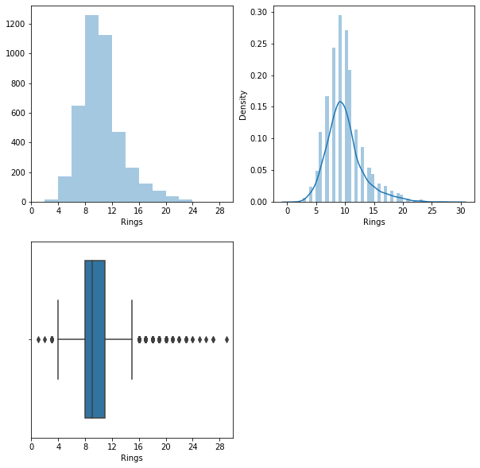

Bi - Variate Analysis

In [158]:

plt**.**scatter(data**.**Rings, data**.**Height)

Out[158]:

<matplotlib.collections.PathCollection at 0x7fd586464910>

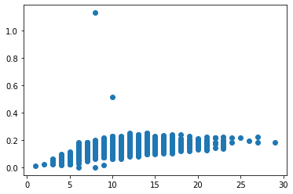

Multi-Variate Analysis

In [159]:

pd**.**plotting**.**scatter_matrix(data**.**loc[:, "Sex":"Rings"], diagonal**=**"kde",figsize**=**(20,15))

plt**.**show()

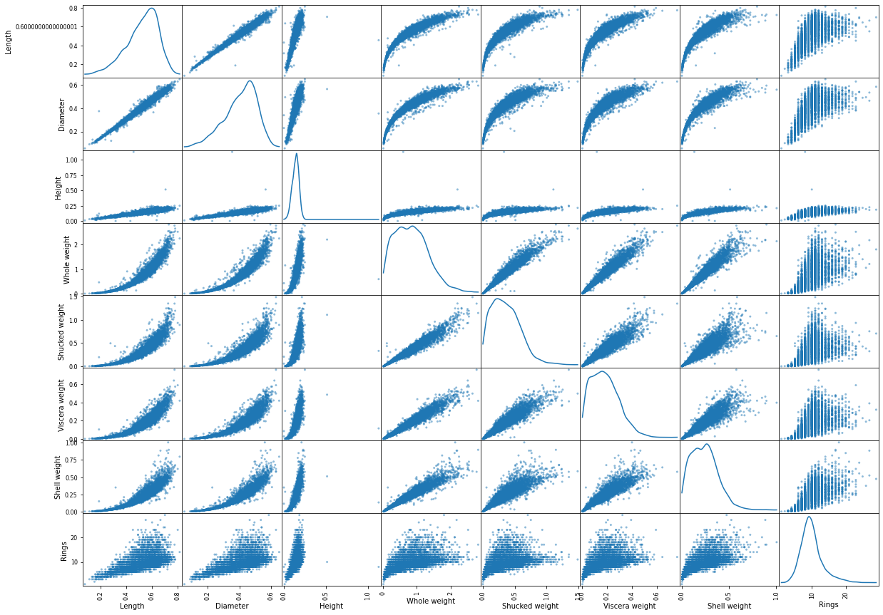

In [160]:

plt**.**figure(figsize**=**(10, 10))

corr **=** data**.**corr()

_ **=** sns**.**heatmap(corr, annot**=True**)

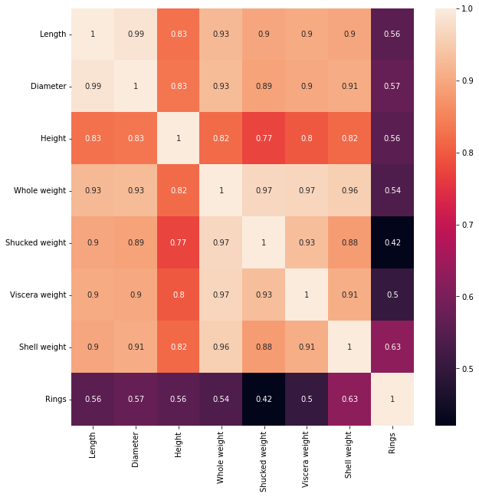

In [161]:

numerical_features **=** data**.**select_dtypes(include **=** [np**.**number])**.**columns

categorical_features **=** data**.**select_dtypes(include **=** [np**.**object])**.**columns

numerical_features

categorical_features

/usr/local/lib/python3.7/dist-packages/ipykernel_launcher.py:2: DeprecationWarning: `np.object` is a deprecated alias for the builtin `object`. To silence this warning, use `object` by itself. Doing this will not modify any behavior and is safe.

Deprecated in NumPy 1.20; for more details and guidance: https://numpy.org/devdocs/release/1.20.0-notes.html#deprecations

Out[161]:

Index(['Sex'], dtype='object')

In [162]:

plt**.**figure(figsize **=** (20,7))

sns**.**heatmap(data[numerical_features]**.**corr(),annot **=** **True**)

Out[162]:

<matplotlib.axes._subplots.AxesSubplot at 0x7fd572f5f550>

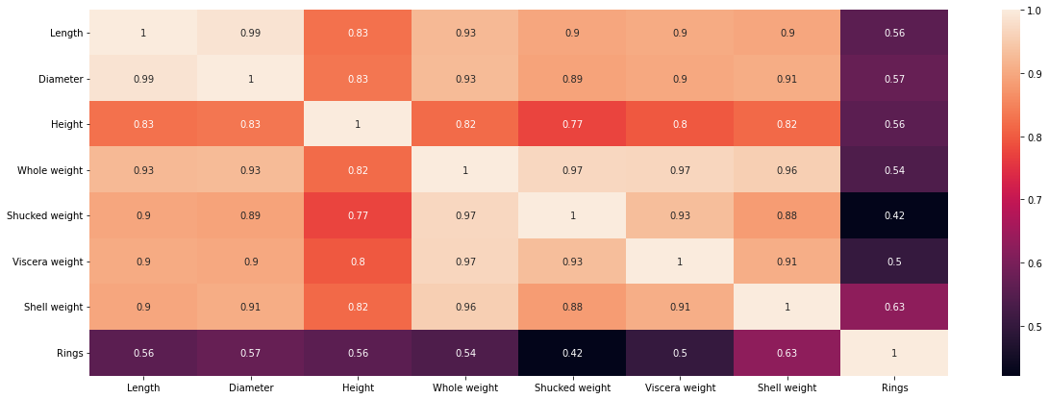

**4. Perform descriptive statistics on the dataset.**

In [163]:

data**.**columns

Out[163]:

Index(['Sex', 'Length', 'Diameter', 'Height', 'Whole weight', 'Shucked weight',

'Viscera weight', 'Shell weight', 'Rings'],

dtype='object')

In [164]:

data[['Length', 'Diameter', 'Height', 'Whole weight', 'Shucked weight','Viscera weight', 'Shell weight', 'Rings']]**.**mean()

Out[164]:

Length 0.523992

Diameter 0.407881

Height 0.139516

Whole weight 0.828742

Shucked weight 0.359367

Viscera weight 0.180594

Shell weight 0.238831

Rings 9.933684

dtype: float64

In [165]:

data[['Length', 'Diameter', 'Height', 'Whole weight', 'Shucked weight','Viscera weight', 'Shell weight', 'Rings']]**.**median()

Out[165]:

Length 0.5450

Diameter 0.4250

Height 0.1400

Whole weight 0.7995

Shucked weight 0.3360

Viscera weight 0.1710

Shell weight 0.2340

Rings 9.0000

dtype: float64

In [166]:

data[['Length', 'Diameter', 'Height', 'Whole weight', 'Shucked weight','Viscera weight', 'Shell weight', 'Rings']]**.**mode()

Out[166]:

|  | **Length** | **Diameter** | **Height** | **Whole weight** | **Shucked weight** | **Viscera weight** | **Shell weight** | **Rings** |
| --- | --- | --- | --- | --- | --- | --- | --- | --- |
| **0** | 0.550 | 0.45 | 0.15 | 0.2225 | 0.175 | 0.1715 | 0.275 | 9.0 |
| **1** | 0.625 | NaN | NaN | NaN | NaN | NaN | NaN | NaN |

In [167]:

data[['Length', 'Diameter', 'Height', 'Whole weight', 'Shucked weight','Viscera weight', 'Shell weight', 'Rings']]**.**sum()

Out[167]:

Length 2188.7150

Diameter 1703.7200

Height 582.7600

Whole weight 3461.6560

Shucked weight 1501.0780

Viscera weight 754.3395

Shell weight 997.5965

Rings 41493.0000

dtype: float64

In [168]:

data[['Length', 'Diameter', 'Height', 'Whole weight', 'Shucked weight','Viscera weight', 'Shell weight', 'Rings']]**.**quantile()

Out[168]:

Length 0.5450

Diameter 0.4250

Height 0.1400

Whole weight 0.7995

Shucked weight 0.3360

Viscera weight 0.1710

Shell weight 0.2340

Rings 9.0000

Name: 0.5, dtype: float64

In [169]:

data[['Length', 'Diameter', 'Height', 'Whole weight', 'Shucked weight','Viscera weight', 'Shell weight', 'Rings']]**.**var()

Out[169]:

Length 0.014422

Diameter 0.009849

Height 0.001750

Whole weight 0.240481

Shucked weight 0.049268

Viscera weight 0.012015

Shell weight 0.019377

Rings 10.395266

dtype: float64

In [170]:

data[['Length', 'Diameter', 'Height', 'Whole weight', 'Shucked weight','Viscera weight', 'Shell weight', 'Rings']]**.**std()

Out[170]:

Length 0.120093

Diameter 0.099240

Height 0.041827

Whole weight 0.490389

Shucked weight 0.221963

Viscera weight 0.109614

Shell weight 0.139203

Rings 3.224169

dtype: float64

In [171]:

data[['Length', 'Diameter', 'Height', 'Whole weight', 'Shucked weight','Viscera weight', 'Shell weight', 'Rings']]**.**skew()

Out[171]:

Length -0.639873

Diameter -0.609198

Height 3.128817

Whole weight 0.530959

Shucked weight 0.719098

Viscera weight 0.591852

Shell weight 0.620927

Rings 1.114102

dtype: float64

In [172]:

data[['Length', 'Diameter', 'Height', 'Whole weight', 'Shucked weight','Viscera weight', 'Shell weight', 'Rings']]**.**min()

Out[172]:

Length 0.0750

Diameter 0.0550

Height 0.0000

Whole weight 0.0020

Shucked weight 0.0010

Viscera weight 0.0005

Shell weight 0.0015

Rings 1.0000

dtype: float64

In [173]:

data[['Length', 'Diameter', 'Height', 'Whole weight', 'Shucked weight','Viscera weight', 'Shell weight', 'Rings']]**.**max()

Out[173]:

Length 0.8150

Diameter 0.6500

Height 1.1300

Whole weight 2.8255

Shucked weight 1.4880

Viscera weight 0.7600

Shell weight 1.0050

Rings 29.0000

dtype: float64

**5. Check for Missing values and deal with them.**

In [174]:

data**.**isnull()**.**sum()

Out[174]:

Sex 0

Length 0

Diameter 0

Height 0

Whole weight 0

Shucked weight 0

Viscera weight 0

Shell weight 0

Rings 0

dtype: int64

There is no missing values

**6. Find the outliers and replace them outliers**

In [175]:

data **=** pd**.**get_dummies(data)

dummy_data **=** data**.**copy()

In [176]:

data**.**boxplot( rot **=** 90, figsize**=**(20,5))

Out[176]:

<matplotlib.axes._subplots.AxesSubplot at 0x7fd572f4ba10>

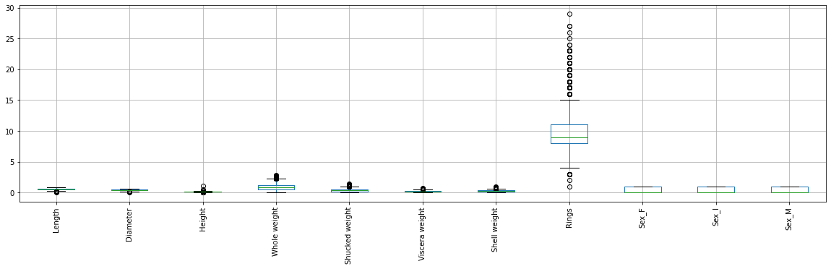

In [177]:

data['age'] **=** data['Rings']**+**1.5

In [178]:

var **=** 'Viscera weight'

plt**.**scatter(x **=** data[var], y **=** data['age'],)

plt**.**grid(**True**)

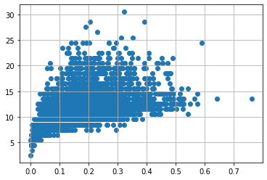

In [179]:

data**.**drop(data[(data['Viscera weight']**>** 0.5) **&** (data['age'] **<** 20)]**.**index, inplace**=True**)

data**.**drop(data[(data['Viscera weight']**<**0.5) **&** (data['age'] **>** 25)]**.**index, inplace**=True**)

In [180]:

var **=** 'Shell weight'

plt**.**scatter(x **=** data[var], y **=** data['age'],)

plt**.**grid(**True**)

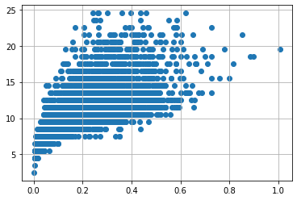

In [181]:

data**.**drop(data[(data['Shucked weight']**>=** 1) **&** (data['age'] **<** 20)]**.**index, inplace**=True**)

data**.**drop(data[(data['Shucked weight']**<**1) **&** (data['age'] **>** 20)]**.**index, inplace**=True**)

In [182]:

var **=** 'Whole weight'

plt**.**scatter(x **=** data[var], y **=** data['age'],)

plt**.**grid(**True**)

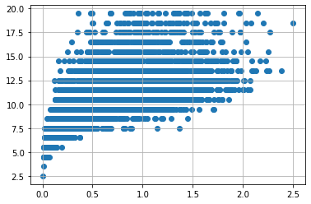

In [183]:

data**.**drop(data[(data['Whole weight']**>=** 2.5) **&** (data['age'] **<** 25)]**.**index, inplace**=True**)

data**.**drop(data[(data['Whole weight']**<**2.5) **&** (data['age'] **>** 25)]**.**index, inplace**=True**)

In [184]:

var **=** 'Diameter'

plt**.**scatter(x **=** data[var], y **=** data['age'],)

plt**.**grid(**True**)

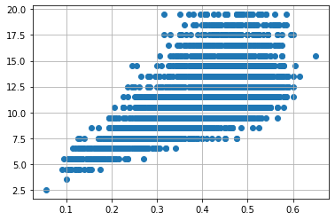

In [185]:

data**.**drop(data[(data['Diameter']**<**0.1) **&** (data['age'] **<** 5)]**.**index, inplace**=True**)

data**.**drop(data[(data['Diameter']**<**0.6) **&** (data['age'] **>** 25)]**.**index, inplace**=True**)

data**.**drop(data[(data['Diameter']**>=**0.6) **&** (data['age']**<** 25)]**.**index, inplace**=True**)

In [186]:

var **=** 'Height'

plt**.**scatter(x **=** data[var], y **=** data['age'],)

plt**.**grid(**True**)

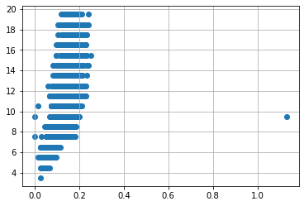

In [187]:

data**.**drop(data[(data['Height']**>**0.4) **&** (data['age'] **<** 15)]**.**index, inplace**=True**)

data**.**drop(data[(data['Height']**<**0.4) **&** (data['age'] **>** 25)]**.**index, inplace**=True**)

In [188]:

var **=** 'Length'

plt**.**scatter(x **=** data[var], y **=** data['age'],)

plt**.**grid(**True**)

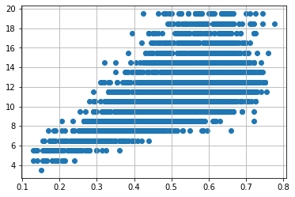

In [189]:

data**.**drop(data[(data['Length']**<**0.1) **&** (data['age'] **<** 5)]**.**index, inplace**=True**)

data**.**drop(data[(data['Length']**<**0.8) **&** (data['age'] **>** 25)]**.**index, inplace**=True**)

data**.**drop(data[(data['Length']**>=**0.8) **&** (data['age']**<** 25)]**.**index, inplace**=True**)

**7. Check for Categorical columns and perform encoding.**

In [190]:

**from** scipy **import** stats

z**=** np**.**abs(stats**.**zscore(data**.**select_dtypes(include**=**[np**.**number])))

print(z)

Length Diameter Height Whole weight Shucked weight \

0 0.544555 0.399071 1.128902 0.620330 0.594508

1 1.433400 1.424312 1.261866 1.247197 1.198628

2 0.090335 0.164811 0.065193 0.266155 0.439854

3 0.671532 0.399071 0.331120 0.615984 0.638005

4 1.602703 1.526836 1.527793 1.291740 1.246958

... ... ... ... ... ...

4172 0.386616 0.472383 0.732590 0.190143 0.108688

4173 0.598246 0.369859 0.065193 0.361798 0.442162

4174 0.682898 0.728693 1.796299 0.818097 0.860213

4175 0.894528 0.831217 0.333699 0.641009 0.886794

4176 1.614069 1.548885 1.530372 2.496623 2.890056

Viscera weight Shell weight Rings Sex_F Sex_I Sex_M \

0 0.711684 0.611842 1.908736 0.666846 0.704866 1.332557

1 1.217824 1.221744 0.952190 0.666846 0.704866 1.332557

2 0.321234 0.154415 0.236958 1.499596 0.704866 0.750437

3 0.586355 0.573723 0.120657 0.666846 0.704866 1.332557

4 1.304590 1.336101 0.952190 0.666846 1.418709 0.750437

... ... ... ... ... ... ...

4172 0.618738 0.142913 0.478273 1.499596 0.704866 0.750437

4173 0.382540 0.230586 0.120657 0.666846 0.704866 1.332557

4174 1.086314 0.592716 0.236958 0.666846 0.704866 1.332557

4175 0.830835 0.501230 0.120657 1.499596 0.704866 0.750437

4176 1.944341 2.018363 0.835889 0.666846 0.704866 1.332557

age

0 1.908736

1 0.952190

2 0.236958

3 0.120657

4 0.952190

... ...

4172 0.478273

4173 0.120657

4174 0.236958

4175 0.120657

4176 0.835889

[4022 rows x 12 columns]

In [191]:

data_o **=** data[(z **<** 3)**.**all(axis**=**1)]

In [192]:

low_cardinality_cols **=** [cname **for** cname **in** data_o**.**columns **if**

data_o[cname]**.**nunique() **<** 10 **and**

data_o[cname]**.**dtype **==** "object"]

numeric_cols **=** [cname **for** cname **in** data_o**.**columns **if**

data_o[cname]**.**dtype **in** ['int64','float64']]

my_cols **=** low_cardinality_cols **+** numeric_cols

data_predictors **=** data_o[my_cols]

In [193]:

print("Shape of Abalones with outliers: "**+** str(data**.**shape) ,

"Shape of Abalones without outliers: " **+** str(data_o**.**shape))

Shape of Abalones with outliers: (4022, 12) Shape of Abalones without outliers: (3973, 12)

In [194]:

data_encoded_predictors **=** pd**.**get_dummies(data_predictors)

**8. Split the data into dependent and independent variables.**

In [195]:

x**=** data**.**iloc[:,3:**-**1]

y**=**data**.**iloc[:,**-**1]

x**.**head()

Out[195]:

|  | **Whole weight** | **Shucked weight** | **Viscera weight** | **Shell weight** | **Rings** | **Sex_F** | **Sex_I** | **Sex_M** |
| --- | --- | --- | --- | --- | --- | --- | --- | --- |
| **0** | 0.5140 | 0.2245 | 0.1010 | 0.150 | 15 | 0 | 0 | 1 |
| **1** | 0.2255 | 0.0995 | 0.0485 | 0.070 | 7 | 0 | 0 | 1 |
| **2** | 0.6770 | 0.2565 | 0.1415 | 0.210 | 9 | 1 | 0 | 0 |
| **3** | 0.5160 | 0.2155 | 0.1140 | 0.155 | 10 | 0 | 0 | 1 |
| **4** | 0.2050 | 0.0895 | 0.0395 | 0.055 | 7 | 0 | 1 | 0 |

In [196]:

x **=** data**.**iloc[:, 3:13]**.**values

y **=** data**.**iloc[:, 3:13]**.**values

In [197]:

**from** sklearn.model_selection **import** train_test_split

x_train, x_test, y_train, y_test **=** train_test_split(x, y, test_size **=** 0.25, random_state **=** 0)

print(x_train**.**shape)

print(y_train**.**shape)

print(x_test**.**shape)

print(y_test**.**shape)

(3016, 9)

(3016, 9)

(1006, 9)

(1006, 9)

**9. Scale the independent variables**

In [198]:

**from** sklearn.preprocessing **import** StandardScaler

sc **=** StandardScaler()

x_train **=** sc**.**fit_transform(x_train)

x_test **=** sc**.**fit_transform(x_test)

x_train **=** pd**.**DataFrame(x_train)

x_train**.**head()

Out[198]:

|  | **0** | **1** | **2** | **3** | **4** | **5** | **6** | **7** | **8** |
| --- | --- | --- | --- | --- | --- | --- | --- | --- | --- |
| **0** | -0.769217 | -0.763992 | -0.861091 | -0.660073 | 0.846424 | -0.681232 | 1.429472 | -0.740979 | 0.846424 |
| **1** | -1.469024 | -1.471684 | -1.374250 | -1.431125 | -0.236960 | -0.681232 | -0.699559 | 1.349566 | -0.236960 |
| **2** | 1.559468 | 1.118323 | 2.275953 | 1.210298 | 1.929808 | -0.681232 | -0.699559 | 1.349566 | 1.929808 |
| **3** | 1.245047 | 1.254511 | 1.399711 | 1.248469 | 0.846424 | -0.681232 | -0.699559 | 1.349566 | 0.846424 |
| **4** | 0.546332 | 0.213645 | 1.554627 | 0.408710 | 0.846424 | 1.467928 | -0.699559 | -0.740979 | 0.846424 |

**10. Split the data into training and testing**

In [199]:

train, test **=** train_test_split(data, test_size**=**0.25, random_state**=**1)

print('Train data points :', len(train))

print('Test data points :', len(test))

Train data points : 3016

Test data points : 1006

In [200]:

**from** sklearn.model_selection **import** train_test_split

x_train, x_test, y_train, y_test **=** train_test_split(x, y, test_size **=** 0.25, random_state **=** 0)

print(x_train**.**shape)

print(y_train**.**shape)

print(x_test**.**shape)

print(y_test**.**shape)

(3016, 9)

(3016, 9)

(1006, 9)

(1006, 9)

**11. Build the Model**

In [201]:

**from** sklearn.ensemble **import** RandomForestRegressor

*# instantiate model*

rf **=** RandomForestRegressor(n_jobs**=-**1, *#n_jobs=-1 means that we are using all computer power to fit the model*

random_state**=**14)

*# fit the model*

rf**.**fit(x_train, y_train)

Out[201]:

RandomForestRegressor(n_jobs=-1, random_state=14)

In [202]:

**from** sklearn.linear_model **import** LinearRegression

**from** sklearn.linear_model **import** Lasso

models **=** {'linear_regression':LinearRegression(),

'lasso':Lasso(random_state**=**1),

'decision_tree':DecisionTreeRegressor(random_state**=**1),

'random_forest':RandomForestRegressor(random_state**=**1),

'xgboost':XGBRegressor(random_state**=**1),

}

In [203]:

rf_params **=** {'n_estimators': 200,

'min_samples_split': 2,

'min_samples_leaf': 4,

'max_features': 'sqrt',

'max_depth': **None**,

'bootstrap': **True**}

model **=** RandomForestRegressor(random_state**=**1, **\*\***rf_params)

model**.**fit(x_train, y_train)

Out[203]:

RandomForestRegressor(max_features='sqrt', min_samples_leaf=4, n_estimators=200,

random_state=1)

**12. Train the Model**

In [204]:

X **=** data**.**iloc[:, :**-**1]**.**values

y **=** data**.**iloc[:, **-**1]**.**values

train_X,val_X,train_y,val_y **=** train_test_split(X, y, test_size **=** 0.2, random_state **=** 0)

In [205]:

print("Shape of Training X :",train_X**.**shape)

print("Shape of Validation X :",val_X**.**shape)

print("Shape of Training y :",train_y**.**shape)

print("Shape of Validation y :",val_y**.**shape)

Shape of Training X : (3217, 11)

Shape of Validation X : (805, 11)

Shape of Training y : (3217,)

Shape of Validation y : (805,)

In [206]:

lr **=** LinearRegression()

lr**.**fit(train_X,train_y)

print('Attempting to fit Linear Regressor')

Attempting to fit Linear Regressor

In [207]:

**%%**time

y_pred_val_lr **=** lr**.**predict(val_X)

print('MAE on Validation set :',metrics**.**mean_absolute_error(val_y, y_pred_val_lr))

print("\n")

print('MSE on Validation set :',metrics**.**mean_squared_error(val_y, y_pred_val_lr))

print("\n")

print('RMSE on Validation set :',np**.**sqrt(metrics**.**mean_absolute_error(val_y, y_pred_val_lr)))

print("\n")

print('R2 Score on Validation set :',metrics**.**r2_score(val_y, y_pred_val_lr))

print("\n")

MAE on Validation set : 1.1546319456101628e-15

MSE on Validation set : 3.1821472974893545e-30

RMSE on Validation set : 3.397987559733206e-08

R2 Score on Validation set : 1.0

CPU times: user 6.83 ms, sys: 4.96 ms, total: 11.8 ms

Wall time: 12.7 ms

**13. Test the Model**

In [208]:

**import** numpy **as** np

**import** numpy

**from** sklearn.metrics **import** r2_score

numpy**.**random**.**seed(2)

x **=** numpy**.**random**.**normal(3, 1, 100)

y **=** numpy**.**random**.**normal(150, 40, 100) **/** x

train_x **=** x[:80]

train_y **=** y[:80]

test_x **=** x[80:]

test_y **=** y[80:]

mymodel **=** numpy**.**poly1d(numpy**.**polyfit(train_x, train_y, 4))

r2 **=** r2_score(test_y, mymodel(test_x))

print(r2)

0.8086921460343566

**14. Measure the performance using Metrics.**

In [209]:

**from** sklearn.metrics **import** mean_absolute_error, r2_score, mean_squared_log_error

*# create an evaluation function*

**def** show_score(model):

train_preds**=** model**.**predict(x_train)

test_preds **=** model**.**predict(x_test)

scores **=** {"Training MAE": mean_absolute_error(y_train, train_preds),

"Test MAE": mean_absolute_error(y_test, test_preds),

"Training MSE": mean_squared_log_error(y_train, train_preds),

"Test MSE": mean_squared_log_error(y_test, test_preds),

"Training RMSE": np**.**sqrt(mean_squared_log_error(y_train, train_preds)),

"Test RMSE": np**.**sqrt(mean_squared_log_error(y_test, test_preds)),

"Training R2": r2_score(y_train, train_preds),

"Test R2": r2_score(y_test, test_preds)}

**return** scores

*# fit*

In [210]:

rf**.**fit(x_train, y_train)

Out[210]:

RandomForestRegressor(n_jobs=-1, random_state=14)

In [211]:

show_score(rf)

Out[211]:

{'Training MAE': 0.002969515362511056,

'Test MAE': 0.008333732052131658,

'Training MSE': 3.377316030763978e-05,

'Test MSE': 0.00022606804480543698,

'Training RMSE': 0.0058114679993646855,

'Test RMSE': 0.015035559344614919,

'Training R2': 0.9977286616319563,

'Test R2': 0.984112781560057}

In [211]: